Chapter 15

Transactions

Transaction Concept

Transaction State

Concurrent Executions

Serializability

Recoverability

Implementation of Isolation

Transaction Definition in SQL

Testing for Serializability.

Transaction Concept

A transaction is a unit of program execution that accesses and possibly updates various data items.

E.g. transaction to transfer $50 from account A to account B:

1. read(A)

2. A := A – 50

3. write(A)

4. read(B)

5. B := B + 50

6. write(B)

Two main issues to deal with:

Failures of various kinds, such as hardware failures and system crashes

Concurrent execution of multiple transactions

Example of Fund Transfer

Transaction to transfer $50 from account A to account B:

1. read(A)

2. A := A – 50

3. write(A)

4. read(B)

5. B := B + 50

6. write(B)

Atomicity requirement

if the transaction fails after step 3 and before step 6, money will be “lost” leading to an inconsistent database state

Failure could be due to software or hardware

the system should ensure that updates of a partially executed transaction are not reflected in the database

Durability requirement — once the user has been notified that the transaction has completed (i.e., the transfer of the $50 has taken place), the updates to the database by the transaction must persist even if there are software or hardware failures.

Transaction to transfer $50 from account A to account B:

1. read(A)

2. A := A – 50

3. write(A)

4. read(B)

5. B := B + 50

6. write(B)

Consistency requirement in above example:

the sum of A and B is unchanged by the execution of the transaction

In general, consistency requirements include

Explicitly specified integrity constraints such as primary keys and foreign keys

Implicit integrity constraints

e.g. sum of balances of all accounts, minus sum of loan amounts must equal value of cash-in-hand

A transaction must see a consistent database.

During transaction execution the database may be temporarily inconsistent.

When the transaction completes successfully the database must be consistent

Erroneous transaction logic can lead to inconsistency

Isolation requirement — if between steps 3 and 6, another transaction T2 is allowed to access the partially updated database, it will see an inconsistent database (the sum A + B will be less than it should be).
T1 T2

1. read(A)

2. A := A – 50

3. write(A)
read(A), read(B), print(A+B)

4. read(B)

5. B := B + 50

6. write(B

Isolation can be ensured trivially by running transactions serially

that is, one after the other.

However, executing multiple transactions concurrently has significant benefits, as we will see later.

ACID Properties

Atomicity. Either all operations of the transaction are properly reflected in the database or none are.

Consistency. Execution of a transaction in isolation preserves the consistency of the database.

Isolation. Although multiple transactions may execute concurrently, each transaction must be unaware of other concurrently executing transactions. Intermediate transaction results must be hidden from other concurrently executed transactions.

That is, for every pair of transactions T_{i} and T_{j}, it appears to T_{i} that either T_{j}, finished execution before T_{i} started, or T_{j} started execution after T_{i} finished.

Durability. After a transaction completes successfully, the changes it has made to the database persist, even if there are system failures.

Transaction State

Active – the initial state; the transaction stays in this state while it is executing

Partially committed – after the final statement has been executed.

Failed -- after the discovery that normal execution can no longer proceed.

Aborted – after the transaction has been rolled back and the database restored to its state prior to the start of the transaction. Two options after it has been aborted:

restart the transaction

can be done only if no internal logical error

kill the transaction

Committed – after successful completion.

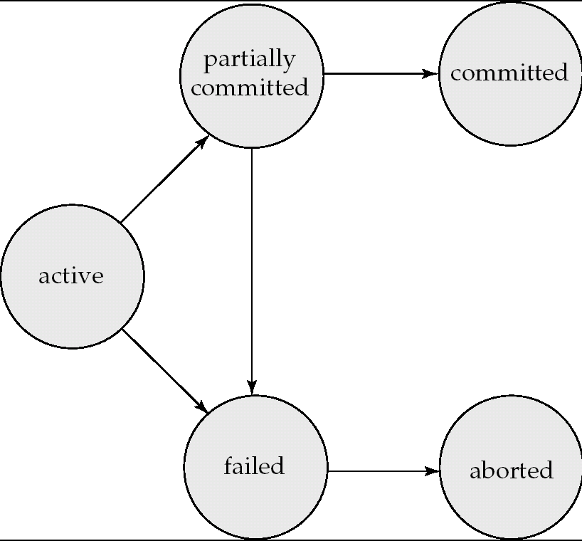

Implementation of Atomicity and Durability

The recovery-management component of a database system implements the support for atomicity and durability.

E.g. the shadow-database scheme:

all updates are made on a shadow copy of the database

db_pointer is made to point to the updated shadow copy after

the transaction reaches partial commit and

all updated pages have been flushed to disk.

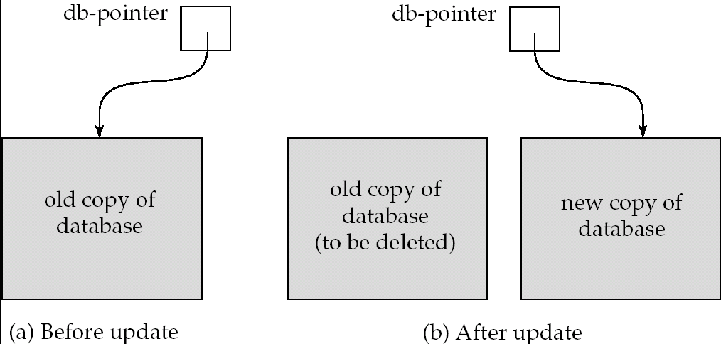

db_pointer always points to the current consistent copy of the database.

In case transaction fails, old consistent copy pointed to by db_pointer can be used, and the shadow copy can be deleted.

The shadow-database scheme:

Assumes that only one transaction is active at a time.

Assumes disks do not fail

Useful for text editors, but

extremely inefficient for large databases (why?)

Variant called shadow paging reduces copying of data, but is still not practical for large databases

Does not handle concurrent transactions

Will study better schemes in Chapter 17.

Concurrent Executions

Multiple transactions are allowed to run concurrently in the system. Advantages are:

increased processor and disk utilization, leading to better transaction throughput

E.g. one transaction can be using the CPU while another is reading from or writing to the disk

reduced average response time for transactions: short transactions need not wait behind long ones.

Concurrency control schemes – mechanisms to achieve isolation

that is, to control the interaction among the concurrent transactions in order to prevent them from destroying the consistency of the database

Will study in Chapter 16, after studying notion of correctness of concurrent executions.

Schedules

Schedule – a sequences of instructions that specify the chronological order in which instructions of concurrent transactions are executed

a schedule for a set of transactions must consist of all instructions of those transactions

must preserve the order in which the instructions appear in each individual transaction.

A transaction that successfully completes its execution will have a commit instructions as the last statement

by default transaction assumed to execute commit instruction as its last step

A transaction that fails to successfully complete its execution will have an abort instruction as the last statement

Schedule 1

Let T₁ transfer $50 from A to B, and T₂ transfer 10% of the balance from A to B.

A serial schedule in which T₁ is followed by T₂ :
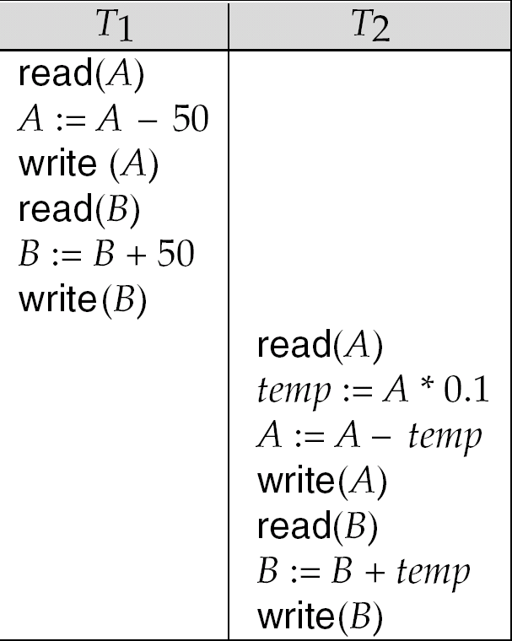

Schedule 2
A serial schedule where T₂ is followed by T₁
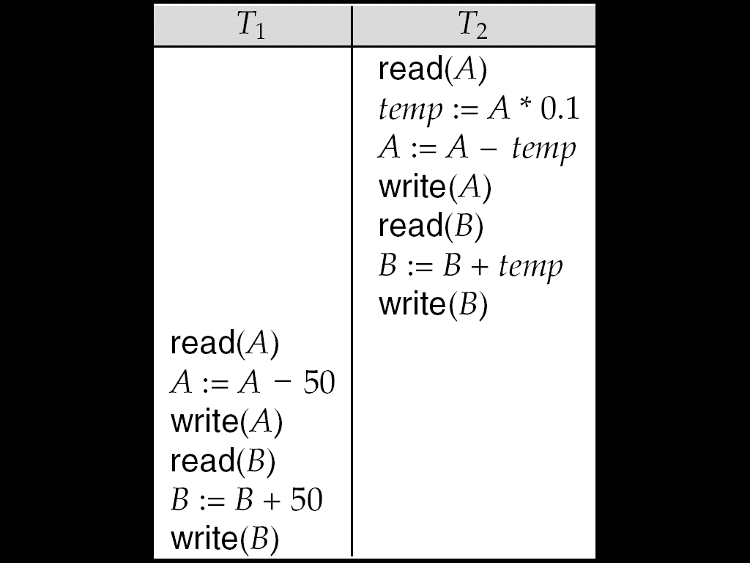

Schedule 3

Let T₁ and T₂ be the transactions defined previously. The following schedule is not a serial schedule, but it is equivalent to Schedule 1.

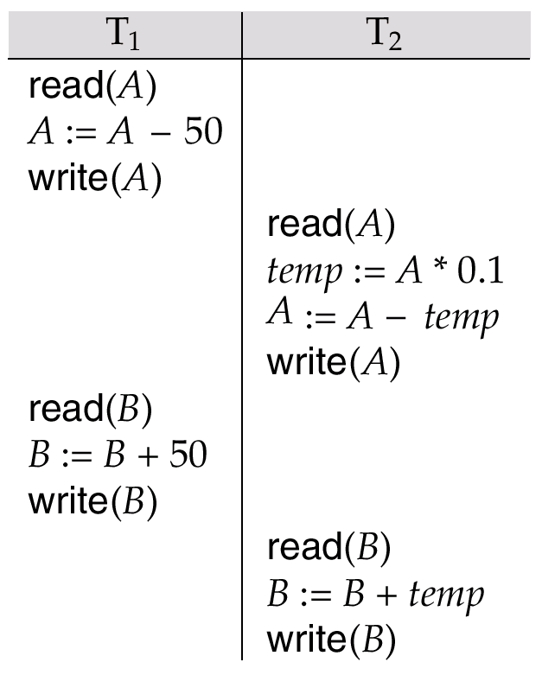
In Schedules 1, 2 and 3, the sum A + B is preserved

Schedule 4

The following concurrent schedule does not preserve the value of (A + B ).

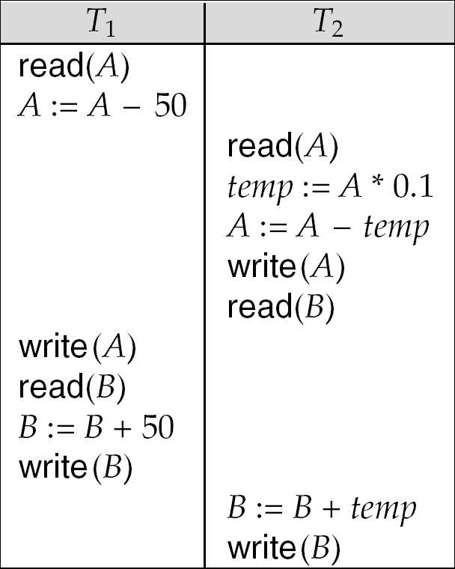

Serializability

Basic Assumption – Each transaction preserves database consistency.

Thus serial execution of a set of transactions preserves database consistency.

A (possibly concurrent) schedule is serializable if it is equivalent to a serial schedule. Different forms of schedule equivalence give rise to the notions of:

1. conflict serializability

2. view serializability

Simplified view of transactions

We ignore operations other than read and write instructions

We assume that transactions may perform arbitrary computations on data in local buffers in between reads and writes.

Our simplified schedules consist of only read and write instructions.

Conflicting Instructions

Instructions l_{i} and l_{j} of transactions T_{i} and T_{j} respectively, conflict if and only if there exists some item Q accessed by both l_{i} and l_{j}, and at least one of these instructions wrote Q.

1. l_{i} = read(Q), l_{j} = read(Q). l_{i} and l_{j} don’t conflict.
2. l_{i} = read(Q), l_{j} = write(Q). They conflict.
3. l_{i} = write(Q), l_{j} = read(Q). They conflict
4. l_{i} = write(Q), l_{j} = write(Q). They conflict

Intuitively, a conflict between l_{i} and l_{j} forces a (logical) temporal order between them.

If l_{i} and l_{j} are consecutive in a schedule and they do not conflict, their results would remain the same even if they had been interchanged in the schedule.

Conflict Serializability

If a schedule S can be transformed into a schedule S´ by a series of swaps of non-conflicting instructions, we say that S and S´ are conflict equivalent.

We say that a schedule S is conflict serializable if it is conflict equivalent to a serial schedule

Schedule 3 can be transformed into Schedule 6, a serial schedule where T₂ follows T₁, by series of swaps of non-conflicting instructions.

Therefore Schedule 3 is conflict serializable.

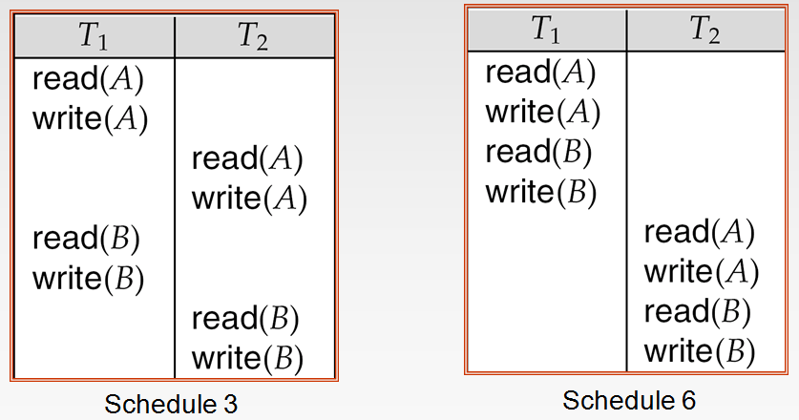

Example of a schedule that is not conflict serializable:

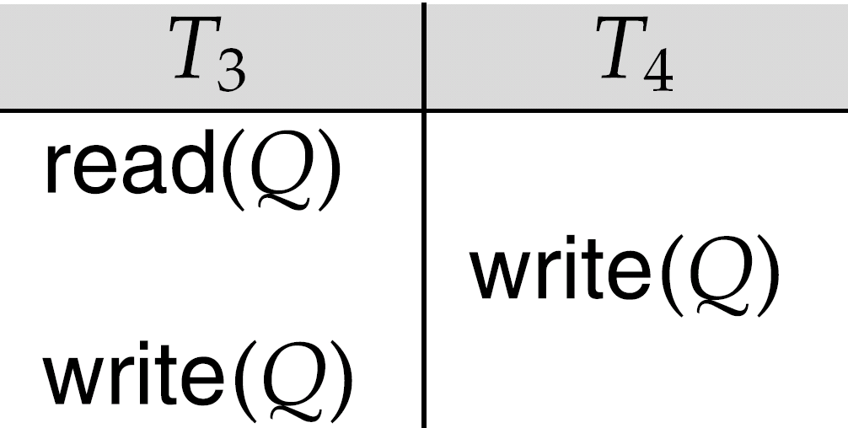

We are unable to swap instructions in the above schedule to obtain either the serial schedule < T₃, T₄ >, or the serial schedule < T₄, T₃ >.

View Serializability

Let S and S´ be two schedules with the same set of transactions. S and S´ are view equivalent if the following three conditions are met, for each data item Q,

If in schedule S, transaction T_{i} reads the initial value of Q, then in schedule S’ also transaction T_{i} must read the initial value of Q.

If in schedule S transaction T_{i} executes read(Q), and that value was produced by transaction T_{j} (if any), then in schedule S’ also transaction T_{i} must read the value of Q that was produced by the same write(Q) operation of transaction T_{j} .

The transaction (if any) that performs the final write(Q) operation in schedule S must also perform the final write(Q) operation in schedule S’.

As can be seen, view equivalence is also based purely on reads and writes alone.

A schedule S is view serializable if it is view equivalent to a serial schedule.

Every conflict serializable schedule is also view serializable.

Below is a schedule which is view-serializable but not conflict serializable.

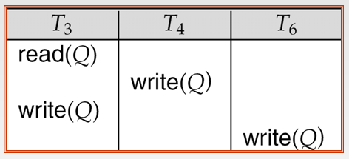

What serial schedule is above equivalent to?

Every view serializable schedule that is not conflict serializable has blind writes.

Other Notions of Serializability

The schedule below produces same outcome as the serial schedule < T₁, T₅ >, yet is not conflict equivalent or view equivalent to it.

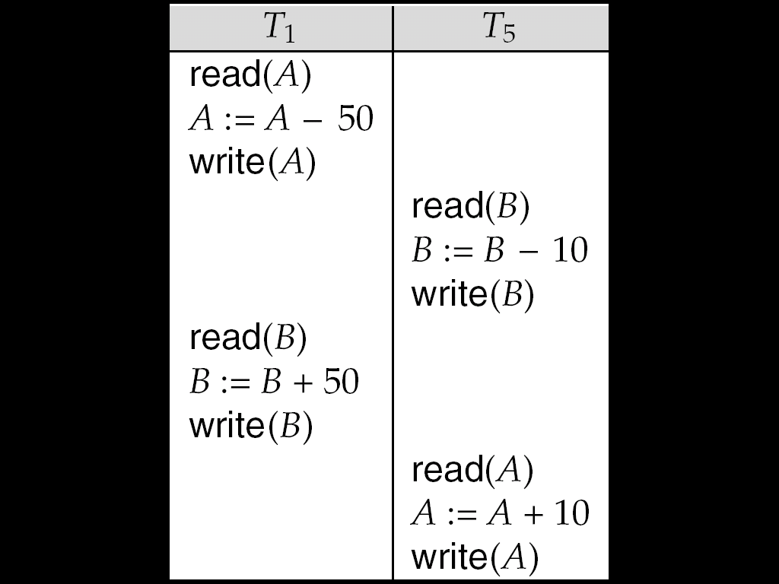

Determining such equivalence requires analysis of operations other than read and write.

Testing for Serializability

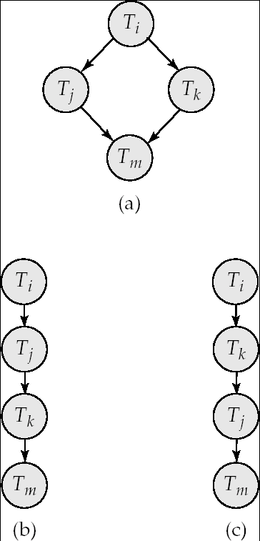

Consider some schedule of a set of transactions T₁, T₂, ..., T_{n}

Precedence graph — a direct graph where the vertices are the transactions (names).

We draw an arc from T_{i} to T_{j} if the two transaction conflict, and T_{i} accessed the data item on which the conflict arose earlier.

We may label the arc by the item that was accessed.

Example 1

Example Schedule (Schedule A) + Precedence Graph

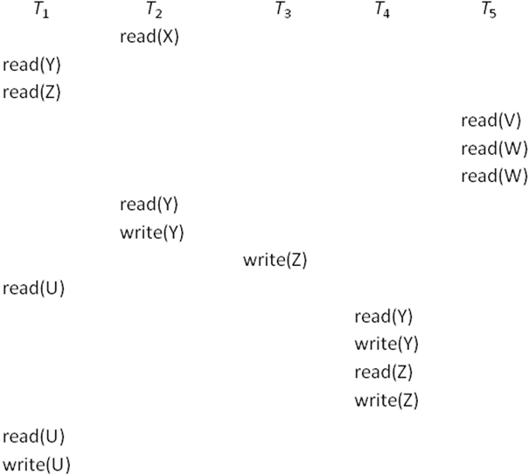

Test for Conflict Serializability

A schedule is conflict serializable if and only if its precedence graph is acyclic.

Cycle-detection algorithms exist which take order n² time, where n is the number of vertices in the graph.

(Better algorithms take order n + e where e is the number of edges.)

If precedence graph is acyclic, the serializability order can be obtained by a topological sorting of the graph.

This is a linear order consistent with the partial order of the graph.

For example, a serializability order for Schedule A would be
T₅ → T₁ → T₃ → T₂ → T₄

Are there others?

Test for View Serializability

The precedence graph test for conflict serializability cannot be used directly to test for view serializability.

Extension to test for view serializability has cost exponential in the size of the precedence graph.

The problem of checking if a schedule is view serializable falls in the class of NP-complete problems.

Thus existence of an efficient algorithm is extremely unlikely.

However practical algorithms that just check some sufficient conditions for view serializability can still be used.

Recoverable Schedules

Recoverable schedule — if a transaction T_{j} reads a data item previously written by a transaction T_{i} , then the commit operation of T_{i} appears before the commit operation of T_{j}.

The following schedule (Schedule 11) is not recoverable if T₉ commits immediately after the read

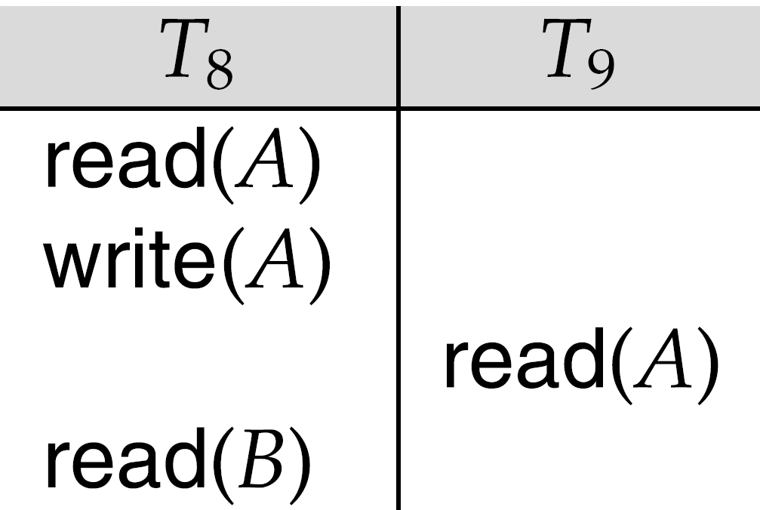

If T₈ should abort, T₉ would have read (and possibly shown to the user) an inconsistent database state. Hence, database must ensure that schedules are recoverable.

Cascading Rollbacks

Cascading rollback – a single transaction failure leads to a series of transaction rollbacks. Consider the following schedule where none of the transactions has yet committed (so the schedule is recoverable)
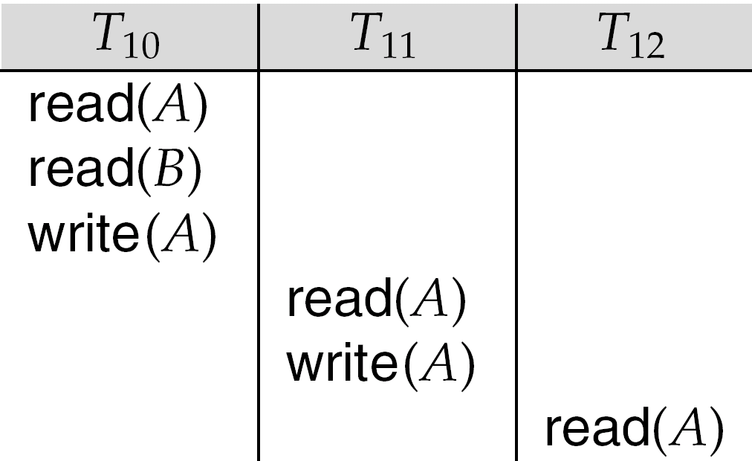
If T₁₀ fails, T₁₁ and T₁₂ must also be rolled back.

Can lead to the undoing of a significant amount of work

Cascadeless Schedules

Cascadeless schedules — cascading rollbacks cannot occur; for each pair of transactions T_{i} and T_{j} such that T_{j} reads a data item previously written by T_{i}, the commit operation of T_{i} appears before the read operation of T_{j}.

Every cascadeless schedule is also recoverable

It is desirable to restrict the schedules to those that are cascadeless

Concurrency Control

A database must provide a mechanism that will ensure that all possible schedules are

either conflict or view serializable, and

are recoverable and preferably cascadeless

A policy in which only one transaction can execute at a time generates serial schedules, but provides a poor degree of concurrency

Are serial schedules recoverable/cascadeless?

Testing a schedule for serializability after it has executed is a little too late!

Goal – to develop concurrency control protocols that will assure serializability.

Concurrency Control vs. Serializability Tests

Concurrency-control protocols allow concurrent schedules, but ensure that the schedules are conflict/view serializable, and are recoverable and cascadeless .

Concurrency control protocols generally do not examine the precedence graph as it is being created

Instead a protocol imposes a discipline that avoids nonseralizable schedules.

We study such protocols in Chapter 16.

Different concurrency control protocols provide different tradeoffs between the amount of concurrency they allow and the amount of overhead that they incur.

Tests for serializability help us understand why a concurrency control protocol is correct.

Weak Levels of Consistency

Some applications are willing to live with weak levels of consistency, allowing schedules that are not serializable

E.g. a read-only transaction that wants to get an approximate total balance of all accounts

E.g. database statistics computed for query optimization can be approximate (why?)

Such transactions need not be serializable with respect to other transactions

Tradeoff accuracy for performance

Levels of Consistency in SQL-92

Serializable — default

Repeatable read — only committed records to be read, repeated reads of same record must return same value. However, a transaction may not be serializable – it may find some records inserted by a transaction but not find others.

Read committed — only committed records can be read, but successive reads of record may return different (but committed) values.

Read uncommitted — even uncommitted records may be read.

Transaction Definition in SQL

Data manipulation language must include a construct for specifying the set of actions that comprise a transaction.

In SQL, a transaction begins implicitly.

A transaction in SQL ends by:

Commit work commits current transaction and begins a new one.

Rollback work causes current transaction to abort.

In almost all database systems, by default, every SQL statement also commits implicitly if it executes successfully

Implicit commit can be turned off by a database directive

E.g. in JDBC, connection.setAutoCommit(false);

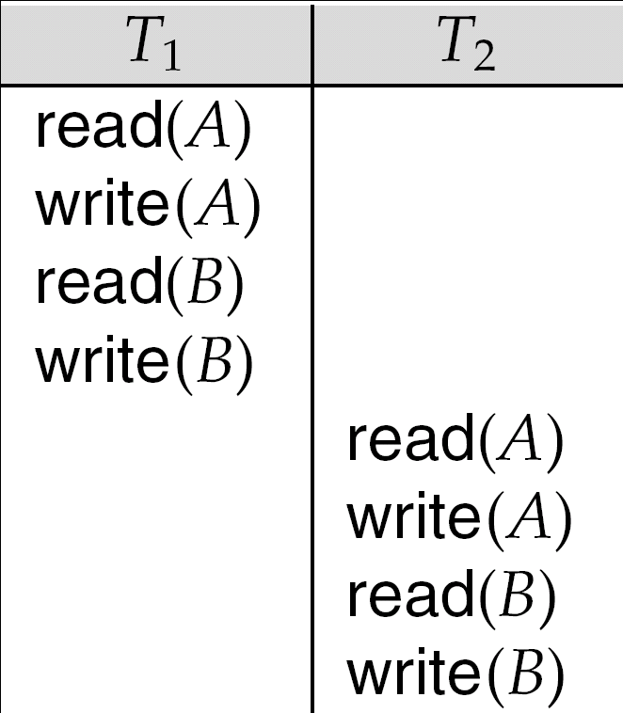

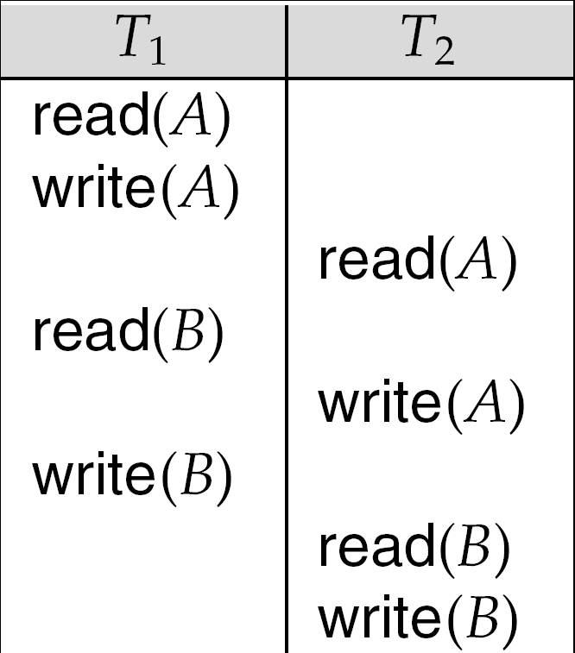

Schedule 7

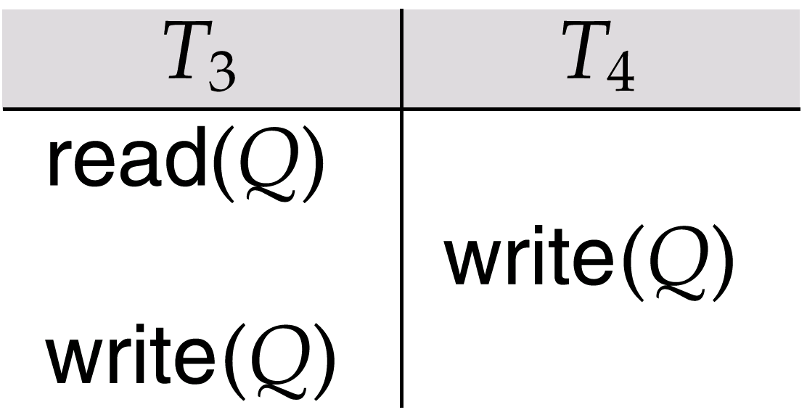

Precedence Graph for
(a) Schedule 1 and (b) Schedule 2

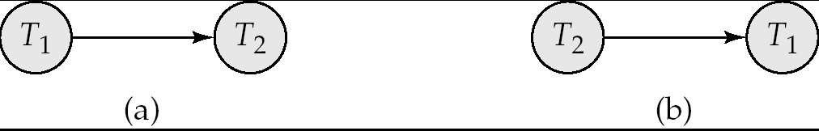

Precedence Graph
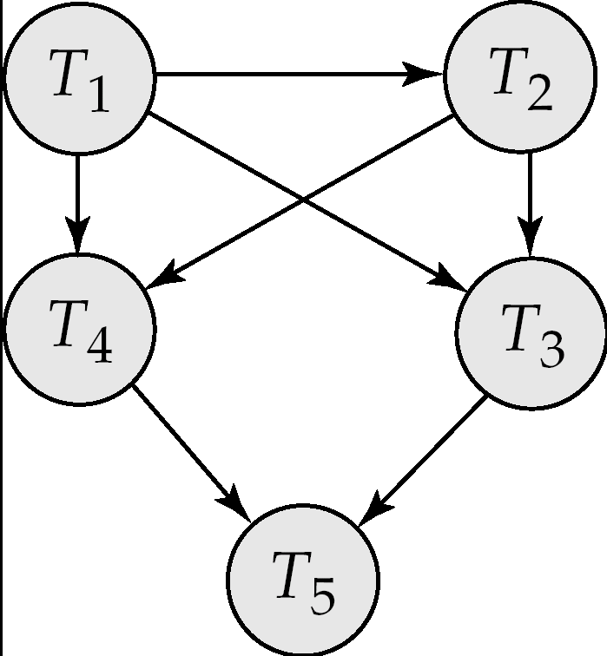

fig. 15.21

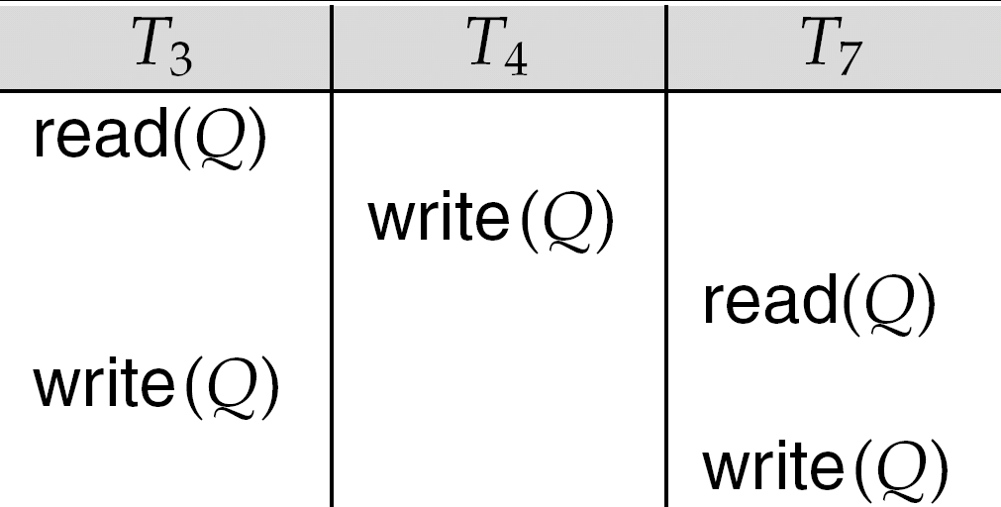

Implementation of Isolation

Schedules must be conflict or view serializable, and recoverable, for the sake of database consistency, and preferably cascadeless.

A policy in which only one transaction can execute at a time generates serial schedules, but provides a poor degree of concurrency.

Concurrency-control schemes tradeoff between the amount of concurrency they allow and the amount of overhead that they incur.

Some schemes allow only conflict-serializable schedules to be generated, while others allow view-serializable schedules that are not conflict-serializable.

Figure 15.6

